

**MAHARASHTRA STATE BOARD OF TECHNICAL EDUCATION,**

**MUMBAI**

**Report On**

**Industrial Training**

**(Internship)**

**(22049)**



**Computer Engineering Programme**

**(“I” Scheme Curriculum)**

**Institute Code: 0059**

**Maharashtra State Board of Technical Education,**

**Mumbai**

**Certificate of Completion**

**of Industrial Training**

This is to certify that,

|  |  |  |
| --- | --- | --- |
| **Sr No.** | **Enrollment Number** | **Name of Student** |
| 1. | 1800590069 | Palak Nilesh Agrawal |
| 2. | 1800590097 | Nilesh Dattu Khandekar |
| 3. | 1800590102 | Karishma Rahul Pakale |
| 4. | 1800590124 | Akshay Sudhir Sonawane |
| 5. | 1800590130 | Sejal Dinesh Yadav |

Have successfully completed Industrial Training (22049) at **Sumago Infotech.Pvt Ltd.** from 30/06/2020 to 27/07/2020 (4 weeks) for partial fulfilment towards completion of Diploma in **Computer Engineering** from S.S.V.P.S’s B.S.Deore Polytechnic, Dhule(Inst.Code 0059)

**Mr.A.S.Chaudhari Ms.S.H.Patil**

**Mentor Head**

**External Examiner Prof. P.B. Kachave**

**Principal**

**Certificates**

**Abstract**

This report consists the detailed description that we have we have learned in 4 weeks industrial training at Sumago Infotech pvt.ltd. In these 4 weeks industrial training we have learned HTML, CSS, Bootstrap and we have also done the assignments given to us by the industry. We have also developed a mini-project a website on travel agency.

**Acknowledgement**

We would like to thank Mr. Sudhir Gorade CEO of Sumago Infotech for teaching us web development concepts during 4 weeks training period. We thank our HOD Mrs. S.H.Patil mam for helping us through this training period. We would also like to thank our mentor Mr. A.S. Chaudhari sir for continuously helping us during training period.

**Content**

Chapter No. Title Page no.

Certificate from Institute

Certificate from Industry

Abstract

Acknowledgment

List of Figures

List of Tables

1. Introduction
   1. Introduction of Industrial Training
   2. Objective of Industrial Training
2. Company’s Profile/Background
   1. Company’s history
   2. Organization chart
   3. Company’s Business Activities
   4. Company’s Mission
   5. Company’s Vision
   6. Organization Profile
3. Weekly Job Summary
4. Technical Contents/Report
   1. Assignments
   2. Mini Project
5. Findings and Suggestions
6. Conclusion

|  |  |  |
| --- | --- | --- |
| **Figure No.** | **Title of Figure** | **Page NO.** |
| 4.1 | Time Table using HTML | 10 |
| 4.2 | Admission Form using HTML | 11 |
| 4.3 | Home Page | 12 |
| 4.4 | Home Page | 13 |
| 4.5 | Home Page | 13 |
| 4.6 | Gallery | 14 |
| 4.7 | Booking page | 15 |
| 4.8 | Form page | 15 |
| 4.9 | Contact Us page | 16 |

|  |  |  |
| --- | --- | --- |
| **Table No.** | **Title of Table** | **Page No.** |
| 2.1 | Organization Profile | 6 |

1. **Introduction**
   1. **Introduction of Industrial Training:**

Industrial training is a short duration training course provided in any company or industry to help students to get Industry knowledge. Industrial training is most important for students. It provides practical knowledge to the students and explains how the industry works. It exposes the students to actual working environment and enhances their knowledge and skill from what they have learned in the college.

Industrial Training is an organized activity focused on required skill set, information to improve and enhance the performance or to help students to meet their career goals.Industrial Training bridges the gap in academic curriculum and in the industry. It helps students to learn new technology, stay them updated with market demand, making them aware of new developments and discoveries and develop skills and competencies required to become employable.

* 1. **Objectives of Industrial Training:**

1. Students are exposed to industrial Environment, which cannot be simulated in the Institute.
2. Students will be able to understand the psychology of the workers, their habits, attitudes and approach to problems along the practices followed either of factory or at a site.
3. Students realize the size and scale of industry.
4. Student should get an opportunity to apply their knowledge in problem solving in their project assignment.
5. Students understand the scope, function and the job responsibilities in various departments of an organization.

# Company’s Profile / Background

* 1. **Company’s History:**

**Sumago Infotech** is a company established in Oct 2013. It has industry-specific software expertise in technology, healthcare, financial, media, manufacturing and many other sectors. This company specializes in offering Web Designing, Web Application Development, Mobile App Development, Software Development, Digital Marketing, Software Testing, Quality Assurance Services and many more.

**Sumago Infotech** aspires to be the global sourcing choice of the world market and revolutionizes the way service processes function. To reach out to the common people across the globe and making Information Technology a tool for the “MASS” along with the tool for the “CLASS”. Creating innovative IT solutions and provide IT-enabled services to delight customers worldwide and build Relationships based on Trust, Values and Professionalism.

**Sumago Infotech** has industry-specific software expertise in Technology, Financial, Healthcare, Media, Manufacturing, and many other sectors. The company specializes in offering Web Designing, Web Application Development, Mobile Application Development, Software Development, Digital Marketing, Software Testing, Quality Assurance services, and many more. They are a team of committed innovative, client-sensitive and experienced software professionals who always strive to deliver customized, cost- effective and long-term software solutions that complement our client's objective and result in a satisfied customer.

At Sumago Infotech, They “Strive with Technology” to provide the most effective and affordable service that fulfills their customer’s needs and budget. They provide customized websites and software solutions that suit customer’s company objectives. They always keep involving our customers in an entire process starting from design through deployment, so that your ideas can be incorporate into our work. After deploying website or software they keep working with you to provide continuous support. They also help to promote your businesses by our digital marketing services. Our focus is always on giving a quality product to a customer for which we design attractive websites, by combining creative strategies with innovative technology.

* 1. **Organization chart:**

CEO-Sudhir G.

COO-Sonali G.

HR-Nayan B.

CTO-Sudhir G.

BA(Marketing)-Yogesh B.

Finance Head-Ganesh G.

Project Manager-Satish M.

B.D.E.-Dipti P.

D.M.E.-Divyashri K.

Team Lead-Satish A.

Web Developer

App Developer

Tester

Trainee Developer

Nandkishor W.

Nilesh S.

Pratiksha K.

Yogita B.

Savita H.

Priyanka T.

Nikhil P.

Prasad S.

Rajendra F.

Rohini K.

Prajakta K.

Pranali K.

Vrushali S.

Pranita G.

Srushti P.

Mayuri P.

Kanchan S.

Amol K.

Roshani S.

Tejashri P.

Varsha W.

Latika S.

Pranali J.

Pratiksha P.

Mayuri S.

* 1. **Company’s Business Activities:**

1. Online Examination System
2. ERP
3. Magic Bricks Application
4. Food Delivery Application
5. Online Service Provider Application
6. Home Automation System
7. E-commerce Application
   1. **Company’s Mission :**

At Sumago InfoTech, they “Strive with Technology” to provide the most effective and affordable service that fulfills the customer’s needs and budget. They provide customized websites and software **so**lutions that suit customer’s company Objectives. They always keep involving customers in an entire process starting from design through deployment so that their ideas can be incorporated into their work.

* 1. **Company’s Vision:**

They aspire to be the global sourcing choice of the world market and revolutionize the way service processes function. To reach out to the common people across the globe and making information technology tool for the “MASS” along with a tool for the “CLASS”. Creating innovative IT solutions and provide IT-enabled services to delight customers worldwide and build Relationships based on Trust, Values and Professionalism.

* 1. **Organization Profile**

|  |  |  |
| --- | --- | --- |
| **Sr. no** | **Name** | **Designation** |
| 1. | Sudhir G. | CEO |
| 2. | Sonali G. | COO |
| 3. | Yogesh B. | BA(Marketing) |
| 4. | Ganesh G. | Finance Head |
| 5. | Satish A. | Project Manager |
| 6. | Dipti P. | B.D.E |
| 7. | Divyashri K. | D.M.E |
| 8. | Satish A. | Team Lead |
| 9. | Nandkishor W. | Web Developer |
| 10. | Nilesh S. | Web Developer |
| 11. | Pratiksha K. | Web Developer |
| 12. | Yogita B. | Web Developer |
| 13. | Savita B. | Web Developer |
| 14. | Savita H. | Web Developer |
| 15. | Nikhil P. | App Developer |
| 16. | Prasad S. | App Developer |
| 17. | Rajendra F. | App Developer |
| 18. | Rohini K. | Tester |
| 19. | Priyanka T. | Web Developer |

Table 2.1

1. **Weekly Job Summary**

**Week 1**- We were introduced with the HTML and HTML tags and also we learn how to insert table in our webpage and how to format it.

**Week 2**- We were introduced with the CSS and we learn that how to use bootstrap in css.

**Week 3**- We were introduced with bootstrap and its classes and also its programs. And also how to use bootstrap online, introduction of Domain of website and also it’s Important. We introduced with new language JavaScript and also its example programs.

**Week 4**- We were Introduced the Php language how to declare the variable and how to store the value in the variable. We learned how to store the data in the database, how to insert data in table, how to delete the data from table and how to update the data.

**Week 1: From 30/6/2020 To 4/7/2020**

|  |  |
| --- | --- |
| **Day** | **Activities Carried out** |
| 1 | **Introduction to Sumago Infotech :**  First day was the introduction session of Sumago Infotech and their employees and we get to know about which project have been developed by them. |
| 2 | **Software Development life Cycle :**  In this session there was discussion about the process of software development. |
| 3 | **HTML Basic :**  In this session we learned about basic HTML tags such as heading tag, break tag, paragraph tag, etc. |
| 4 | **HTML :**  In this session we learned to link webpage using link tag and to display image on webpage using image tag. |
| 5 | **Entrepreneurship :**  In this session we had lecture on entrepreneurship .The four friends who started their business when they were students, shared their journey with us. |
| 6 | **No Session** |

**Week 2: From 6/7/2020 To 11/7/2020**

|  |  |
| --- | --- |
| **Day** | **Activities Carried out** |
| 1 | **HTML Form :**  In this session we learned to design HTML form using form tag. |
| 2 | **Out Of The Box Thinking :**  In this session we learned more about thinking. The session was based on that we should think properly before doing anything so that whatever we plan should execute properly. |
| 3 | **CSS :**  In this session we learned CSS (Cascading Style Sheet) and how to add more design to our webpage using three types of CSS i.e. Inline CSS, Internal CSS, External CSS. |
| 4 | **Bootstrap :**  This was the introduction session of bootstrap and we also learned how to install server and editor required to work on bootstrap. |
| 5 | **No Session** |
| 6 | **A Journey From Lecturer To CEO :**  This session was conducted by CEO of Sumago Infotech Mr.Sudhir Gorade where he shared his journey that how he started his own company and how he became a CEO from lecturer. |

**Week 3: From 13/20/2020 To 18/7/2020**

|  |  |
| --- | --- |
| **Day** | **Activities Carried out** |
| 1 | **Bootstrap:**  In this session we learned to display image on webpage using bootstrap. Due to some network issue only the image tag was covered in this session. |
| 2 | **Bootstrap and JavaScript:**  In this session remaining part of bootstrap was covered and introduction to JavaScript was done using PPT. |
| 3 | **Domain :**  In this session we got detailed knowledge about domain, how to publish our website and how to buy domain. |
| 4 | **JavaScript :**  We learned the basics of JavaScript using PPT such as syntax, control structures in JavaScript, etc. |
| 5 | **JavaScript Validation and JQuery validation :**  In this session we learned JavaScript validation and JQuery validation and we also understood difference between both validations. |
| 6 | **Report Writing :**  This whole session was based on report writing. |

**Week 4: From 20/7/2020 To 25/7/2020**

|  |  |
| --- | --- |
| **Day** | **Activities Carried out** |
| 1 | **PHP Introduction :**  In this session there was introduction to PHP. |
| 2 | **PHP Basics :**  In this session we learned about PHP basics i.e. syntax, use, variable, control structures, etc. |
| 3 | **Database Connectivity :**  Introduction to database and query. |
| 4 | **Database and MYSQL Query :**  In this session we learned connection query and insert query. |
| 5 | **Database and MYSQL Query :**  In this session we learned select, update and delete query. |
| 6 | **Project Management :**  In this session we learned to manage project. |

1. **Technical Contents / Report**
2. **Assignments**

During the period of 4 weeks of Industrial Training we have completed following assignments:

1. **Make Timetable of your collage using tags of HMTL and CSS.**

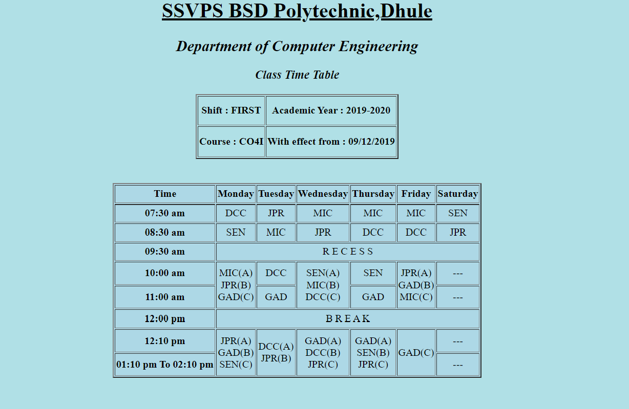

Fig 4.1

This was the first assignment that was given to us. We have developed a webpage displaying time table of our college using HTML tags.

1. **Make an Admission Form using tags of HMTL and CSS.**

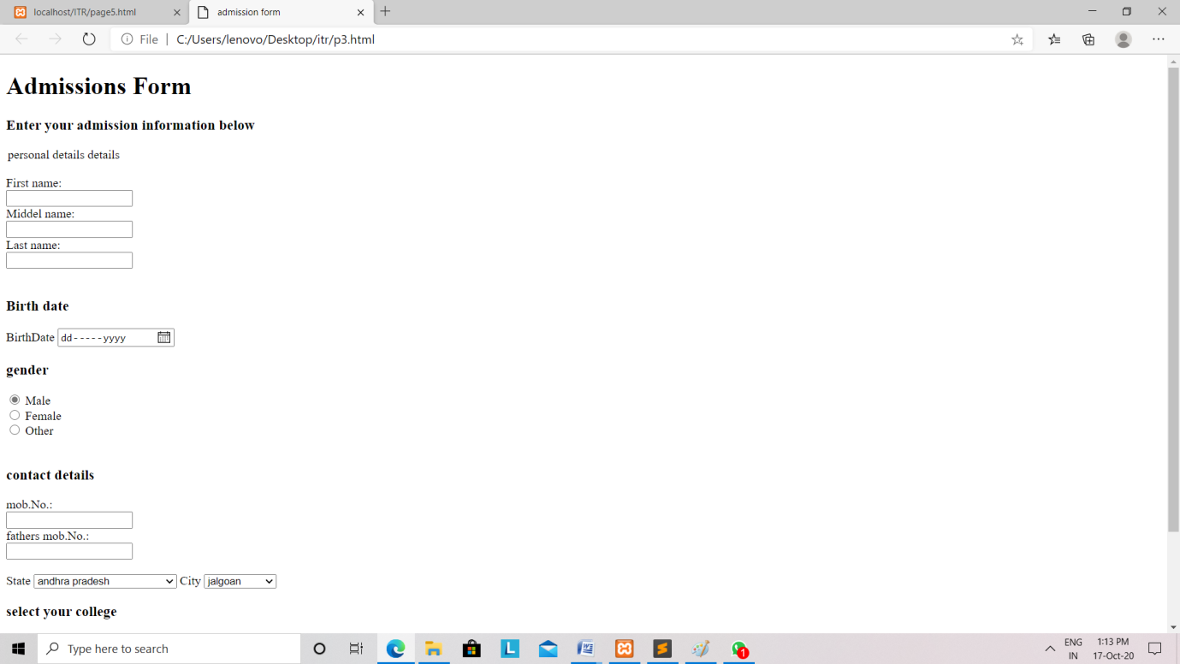

Fig 4.2

We have developed a basic college admission form using HTML tags.

1. **Mini-Project**

We have developed a mini-project having topic website on Travel Agency. We have used all the skill that we have learned in industrial training. We have developed this mini-project by using HTML, CSS, Bootstrap, etc.

On the home page we have displayed the images of different busses to make it look better. We have created a Menu bar containing various menus. By clicking on these menus the user will be directed to another page. We have Jumbotron i.e. Bootstrap component on the home page which has background image and topic displayed on it. We have also written some thoughts/quotes which will attract the reader. On the Book Travel menu we have linked a webpage containing source and destinations that are available for booking travels.

On gallery menu we linked a page displaying images of busses and cars available for booking. On Contact us menu we have linked a webpage display contact details such as address, email, contact number.

**First Page (i.e. Home page) of Website:**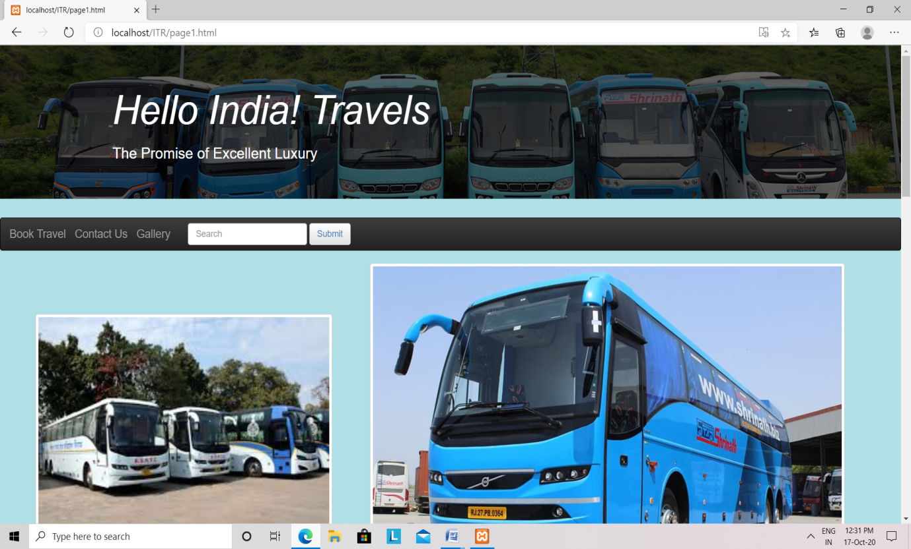 Fig 4.3

The home page displays the images of various busses and menu bar. By clicking on any menu on menu bar the user will be directed to that webpage linked to that menu.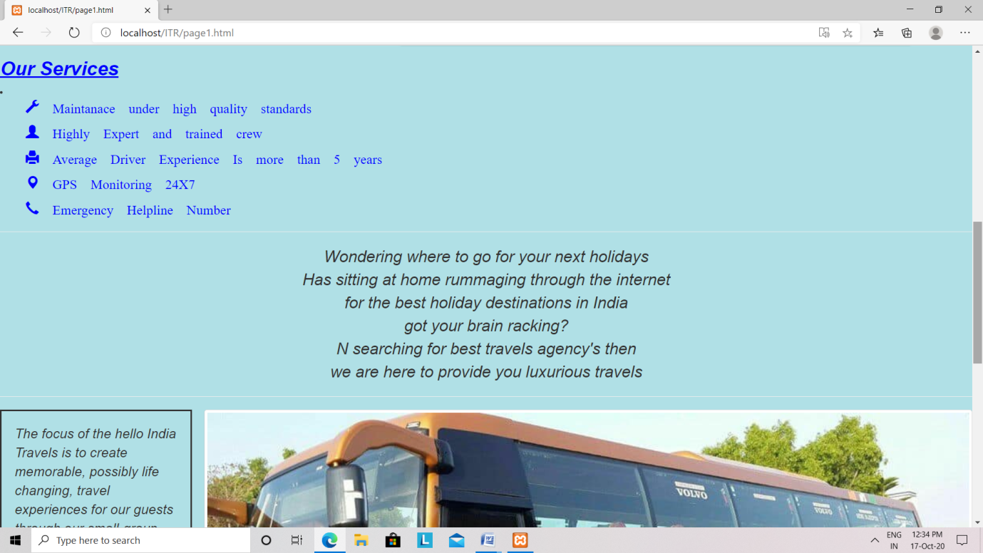Fig 4.4

The home page also contains some attractive quotes and thoughts. It also displays the services using icons that travel agency provides.

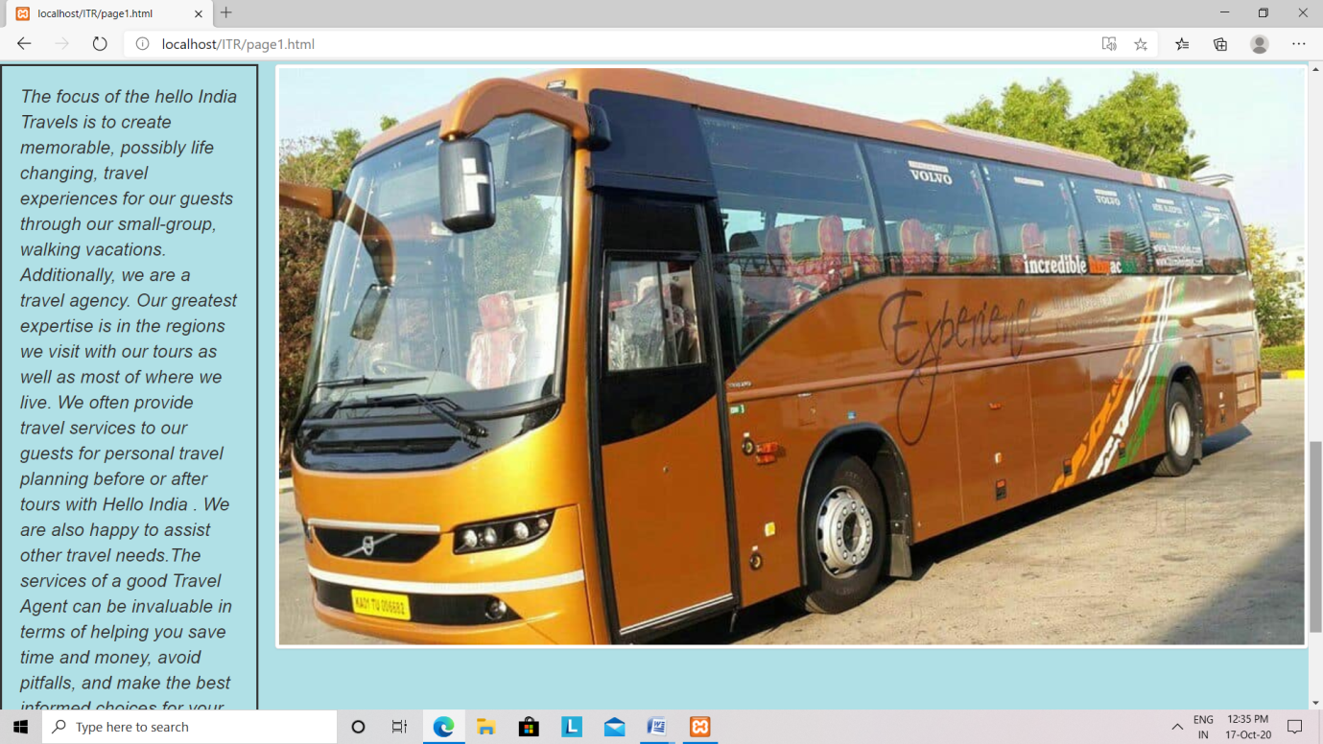Fig 4.5

This page contains combination of text i.e. quote/thought and image that makes the webpage attractive.

**Gallery :**

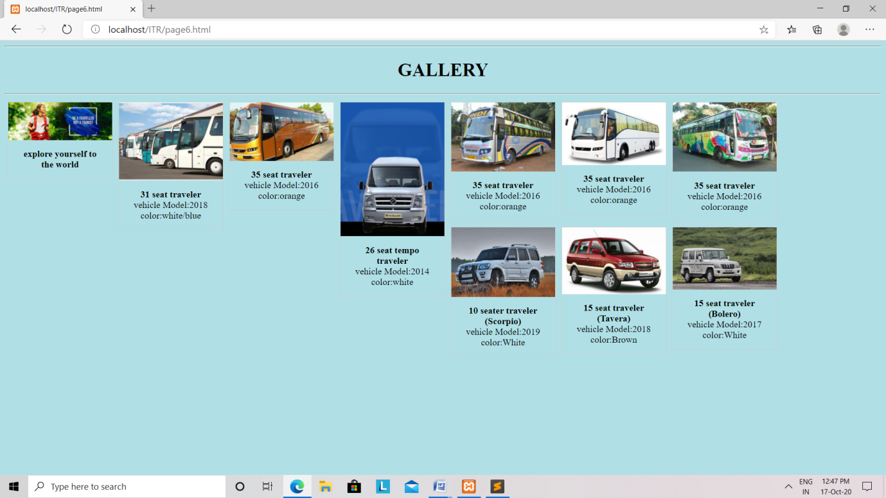Fig 4.6

This page displays the images of various basses and cars with their short description such as model, color that are available for booking .

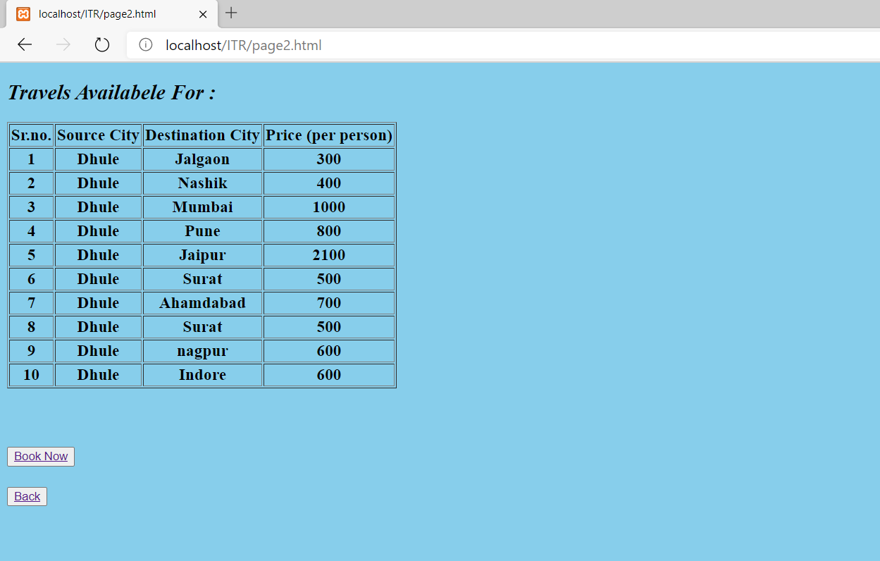Fig 4.7

This page displays the source and destination that are available for booking with their price. It also contains book now and back button. By clicking on book now page it will be directed to next page.

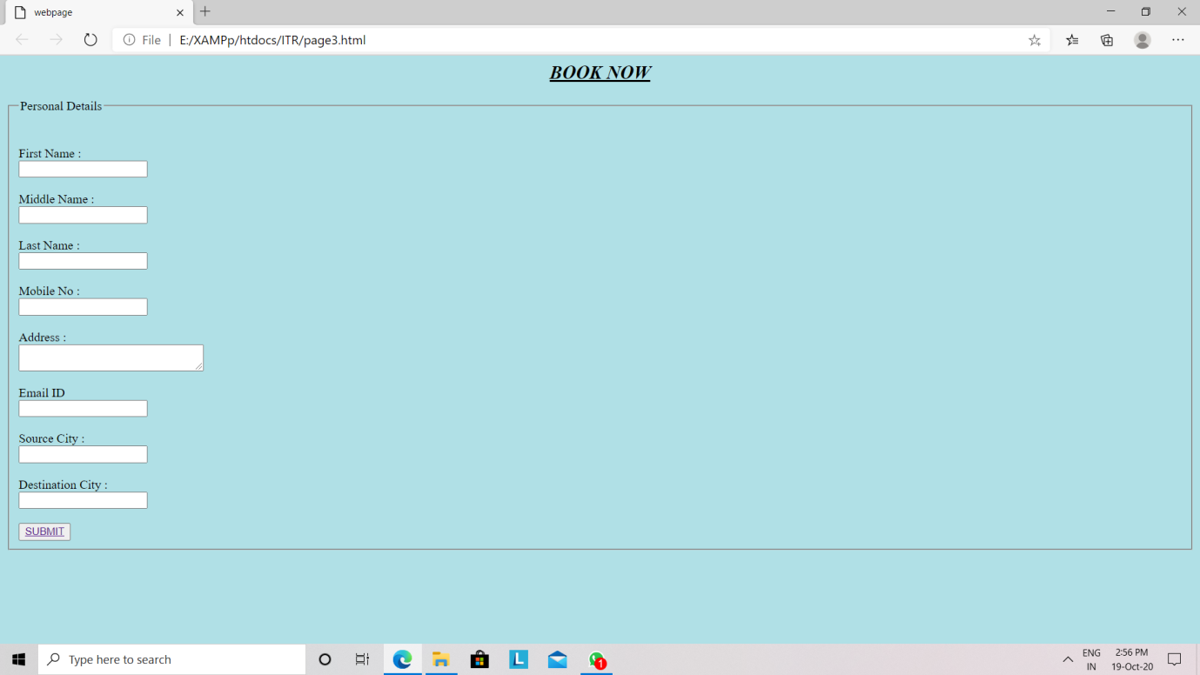Fig 4.8

This page contains the application form that the user needs to fill for booking a travel. It contains various fields such as name, address, contact number, email, source city and destination city.

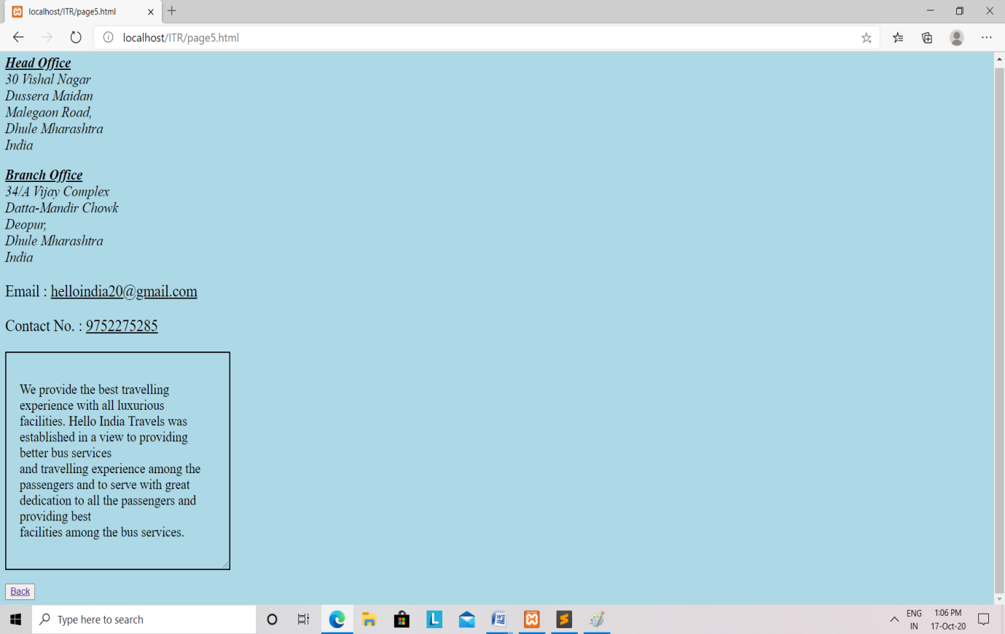Fig 4.9

This webpage displays the details such as address, email, contact number of the travel agency.

1. **Findings & Suggestions**

**Findings**:

During the training period, I was exposed to an environment that is professional in identifying the tasks of employee. From there, I can see how a programmer may play his/her role in a company.

All the staff have their own duties in carrying out the tasks listed. This situation has helped me to work smoothly and always ask when I'm in trouble. If I encounter any problems in the work done, other staff will also be able to assist me as well as provide valuable and helpful guidance for me because their willingness to share experiences and knowledge. Additionally, I always try to assist all staff and ensure that all work is done smoothly and in order.

**Suggestions:**

Companies or firms also play an important role in providing students with guidance on what's appropriate with the courses learned by students. Hence the firm should also provide any form of reward on the work done by them. With the rewards or the effective guidance from the firm itself can inspire the spirit of the student and can also attract them to the field.

The company should avoid giving different directions to students. This is because students will feel confused when getting different instructions from different staff. The mistakes in the assignment can be avoided if the company provides correct and accurate instructions.

1. **Conclusion**

After undergoing 4 weeks of industrial training at Sumago InfoTech pvt.ltd. There is a lot of new knowledge that can be learned and we get to understand altogether on how this firm plays an important role in industrial field, especially in Quantity Surveying. Exposure that have been given to us by Sumago InfoTech pvt.ltd staff about the working and technical aspect is a very meaningful knowledge to us in order to prepare ourselves before stepping into the real work environment on the upcoming days.

I hope with the implication of the Industrial Training, there will be no more anomalous feelings when the students started working after they have finished their course later. The staffs at Sumago InfoTech pvt.ltd are very helpful and friendly. They gave us a lot of exposure on the terms of reference and procedures related to the process of our work. Other than that, the exposure visiting the other Sumago InfoTech pvt.ltd, meeting atmosphere and so on also give a useful knowledge to us. Exposures that were given to us at this firm can provide the picture on a real-life situation, the task and responsibility that would be carried by some people on the field.